Children’s preferences as drivers for family leisure choices: A hybrid choice model
Curtale R., Università della Svizzera italiana
Sarman I., Università della Svizzera italiana

Conference paper STRC 2017

17th Swiss Transport Research Conference
Monte Verità / Ascona, May 17-19 2017
STRC

16

Children’s preferences as drivers for family leisure choices: A hybrid choice model
Curtale R.  Università della Svizzera italiana  Lugano | Sarman I.  Università della Svizzera italiana  Lugano
+41586664170  riccardo.curtale@usi.ch | igor.sarman@usi.ch
First draft – April 2017

Abstract
For some tourist destinations, the role of family tourism and the demand it generates assume a crucial importance in the definition of leisure activities and marketing projects. In this respect, attention is paid to the role of young children in the family unit, identified by modern tourism literature as one of the main influences on family leisure choices. Children’s influence may be mediated by the relevance that parents assign to their role in the family unit and the level of acceptance of their negative responses to children’s requests.
In this paper, we investigate the role of children satisfaction on parents’ leisure related decisions applying discrete choice modeling on SP data. We focus on parent’s attitudes in fulfilling children satisfaction or accepting negative reaction to refuses, considering different impacts on the marginal utility for positive or negative emotions. In our specific framework, accordingly with tourism literature, we consider children as decision influencers (through their levels of satisfaction for the different choice alternatives) while the parents act as decision makers. An hybrid choice model is also presented in order to take into consideration the heterogeneity of parents’ level of tolerance to children’s negative emotions.

Keywords
Family tourism – children’s influence – SP experiment – Hybrid choice model

Introduction
Family tourism is a very relevant component of the global travel demand and the understanding of family decision making is crucial for the travel industry. Anyhow, the understanding of family behavior is a quite complex issue, dealing with different members and different preferences involved in a single decision. Parents are always the final decision maker, but children’s preferences are almost never ignored by parents. The role of children as decision influencers has been recognized by researchers through qualitative studies conducted to parents, but there is still a lack of studies including children’s voices.
Although the importance of this segment for the travel industry, few quantitative studies have been developed so far to capture children’s relevance to influence family behavior. In this paper we propose an experiment to include children’s preferences as a driver for family choices. The parenting style of parents is also investigated in order to understand how the affect of children’s preferences on activity choices at destinations may vary across families.

Literature review
Family tourism is one of the most important segment in the tourism industry, it accounts almost 30% of travel demand and is predicted to grow more than other sectors (Schanzel et al, 2012). For this reason it is crucial for tourism destinations and policy makers to understand family preferences. Starting from the definition, family tourism includes all those group of travellers with at least a child and a parent involved in a leisure activity outside their normal life environment (Carr, 2011; Schanzel et al., 2005). Family decisions, including more than a member for a single choice, are influenced by different preferences determining a single outcome.
In general, family tourist decisions are not taken by a single member only, even though there are few cases in which a single member is dominant for the final decision (e.g. fathers are more likely to decide the mean of transport and mothers are more involved in the purchase of souvenirs) as Kim et al (2010) said. In the majority of the cases, decisions are taken jointly by the parents, with children playing a role of influencers. Thus, according to the literature on family decision making in tourism, children are not real decision makers, but their preferences may influence the final decision (Thornton et al, 1997). The level of influence of children’s preferences on the final decision may vary depending on different factors such as the level of involvement they feel in the choice situation, the number of children involved, the strategy adopted to communicate their preferences and their parents’ attitude (Jenkins, 1979, Gram 2005, Gram, 2007, Martensen et al, 2008). Among different field of consumption, tourism is one in which children are more emotionally involved and so, their contribution to the final decision is stronger if compared to other fields. Tourism decisions can be roughly divided into three different stages: decisions taken before going on holiday (length of stay, accommodation, mean of transport to get to the destination, etc), decisions taken during holiday (choice of restaurants, activities, souvenirs etc) or after the holiday (word of mouth, posting memories, etc). Children’s influence is not the same across the three stages, while their preferences don’t affect very much pre or after holiday decisions, they are more relevant for decisions taken at the destination, such as restaurant choice or the activity to participate (Jenkins, 1978; Hsu et al., 2002; Xu, 2001; Litvin et al., 2004; Jenkins, 1979; Bronner and De Hoog, 2008).
Concerning communication strategies, children have two ways to influence family decisions: unilateral or bilateral strategies. Unilateral strategies are more passive such as playing on emotions or requests, while bilateral are more active and include bargaining, persuasion or reasoning (Bao, Fern & Sheng, 2007).
Another important aspect that affect children’s role for the final decision depends on parents’ willingness to consider their preferences, and the importance they assign to the lattest. The importance that parents attach to children preferences for the final decision depends on their parenting style. Four different parenting styles have been identified in the literature, which depend on the combination of two main dimensions: responsiveness (R) and demandingness (D) (Baumrind, 1971). Responsiveness is defined as the level of affective warmth that parents show in educating children, as well as involvement and acceptance. Demandingness is the propensity of parents to supervise, give discipline, control and confront children when they disobey (Baumrind, 1991). So, four possible parenting style are identified: Authoritarian (demanding, not responsive), Authoritative (responsive, demanding), Neglectful (neither responsive nor demanding), Permissive (responsive, not demanding).

Data collection and description
We adopt SP data and apply discrete choice modelling in order to test the effect of three attributes driving parents’ choices for family activity: cost, distance and children’s satisfaction. Two hypothesis concerning the role of children satisfaction on parental decisions are tested. The first hypothesis (H1) relates to the non-linear effect that children satisfaction has on parental choices, implying that different levels of satisfaction related to a specific activity lead to different marginal utilities for the decision maker. The second hypothesis (H2) relates to the role that parental attitude concerning children satisfaction has when taking leisure-related decisions. This aspect is investigated interacting an attitudinal latent variable with the attribute representing children’s satisfaction. The importance of assessing the effect of parents’ attitudes in the evaluation of kids’ satisfaction is crucial when considering the specific framework of family leisure activities: these represent a moment of joy and relaxation aimed at creating good memories and children’s feelings affect the experience of the whole family.
Data were collected in Ticino (Switzerland) during the summer 2016. Family tourism-friendly locations were selected as sites for data collection and families with children were asked to participate to a paper-and-pencil and tablet-aided survey. This was comprised of several questions organized in different sections and in one of these a discrete choice experiment with various scenarios were present. A total of 172 valid observations were retained for analysis. Table 1 reports the description of the sample interviewed for the specific purpose of this research:
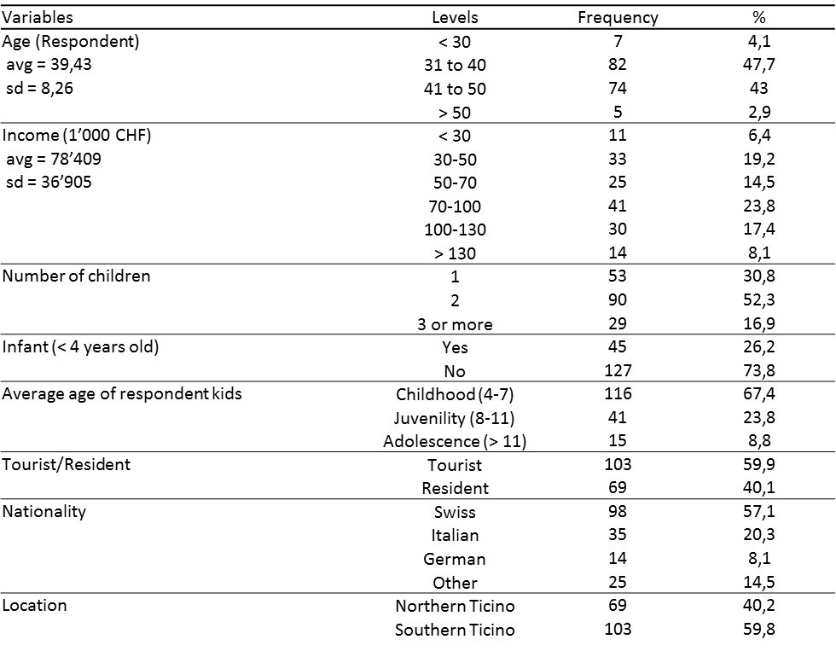
Table 1 - Sample descriptives

Model formalization
In this article an Integrated Choice and Latent Variable model (Walker, 2001; Ben-Akiva et al., 2002) is adopted to account for the role of parental attitudes in involving children’s preferences on leisure activities choices for whole family.
As in a classical multinomial logit, the utility is function of choice attributes and socio demographics characteristics:
$$U_{i,j,t} = {ASC}_{j}+β_{COST}*{COST}_{j,t}+ β_{DISTANCE}*{DISTANCE}_{j,t}+β_{LOCATION}*{LOCATION}_{j,t}$$
$$+β_{SATISFACTION}*{SATISFACTION}_{i,j,t}$$
$$+β_{TOURIST}*{TOURIST}_{i}$$
$$+β_{MEMBERS}*{MEMBERS}_{i}$$
$$+β_{EXPERIENCE}*{EXPERIENCE}_{i,j}$$
$$+ϵ_{i,j,t}$$
COST, DISTANCE, LOCATION and SATISFACTION are choice attributes presented in choice scenarios while the remaining are individual specific determinants and $ϵ_{i,j,t}$ is a classical Gumbel-distributed error term:
- COST of the activity for the whole family (levels depend on number of children and possible discount for residents);
- DISTANCE is the travel time to reach the activity location from the point of interview
- LOCATION is a control variable that consider whether the activity are located in the south or north of Monte Ceneri;
- SATISFACTION of children towards a specific activity (levels of satisfaction are calibrated on children’s previous statements);
- TOURIST is a dummy variable identifying if respondents’ residence is outside Ticino.
- MEMBERS relates to the number of family members carrying out the activity;
- EXPERIENCE is a dummy variable indicating whether the specific activity had been already tried by respondents
Every respondents had to express their choice to 6 different choice tasks. An example of choice task is depicted in table 2:

 | Funicolar Cardada | Boat Trip Lago Maggiore | Lido di Locarno
Distance  Cost  Children’s satisfaction | 40 min  120 CHF  5 | 30 min  100 CHF  -3 | 10 min  76 CHF  0
Choice | 0 | 0 | 0
Table 2 - Example of choice set
In Table 3 is possible to see satisfaction attributes’ levels, depending on children’s stated preferences. Children had to evaluate different activities with a 5 point smiley-based scale, whose description is represented in column one. Depending on their preferences, the attribute has been presented to parents in a numerical scale from -5 (representing activities that children totally dislike) to 5 (representing activities that children like very much)
Children preference | Attribute’s level
very happy (4) | 3,4,5
happy (2) | 1,2,3
indifferent (0) | -1,0,1
unhappy (-2) | -3,-2,-1
very unhappy (-4) | -3,-4,-5
Table 3 - Preference conversion
The impact of different levels SATISFACTION has been estimated through a piecewise specification to check the differences of impact for positive or negative satisfaction levels. More specifically:
$$β_{SATISFACTION}*{SATISFACTION}_{i,j,t}=β_{NEG_SATISFACTION}*{NEG_SATISFACTION}_{i,j,t}$$
$$+β_{POS_SATISFACTION}*{POS_SATISFACTION}_{i,j,t}$$
where:
$${NEG_SATISFACTION}_{i,j,t}=\left\{\begin{aligned}{SATISFACTION}_{i,j,t} if { SATISFACTION}_{i,j,t}≤0 \\ 0 otherwise\end{aligned}\right.$$
$${POS_SATISFACTION}_{i,j,t}=\left\{\begin{aligned}0 if { SATISFACTION}_{i,j,t}≤0 \\ { SATISFACTION}_{i,j,t} otherwise\end{aligned}\right.$$
In the ICLV specification of the model, a latent construct referring to the attitude shown by parents when children complain (indulgent parental attitude) has been included. The latent construct is expressed as a function of socio-demographic variables that we assume have an indirect role in determining choice behaviour via the attitudinal construct. In our case, the LV equation is specified as follows:
$${PARENTAL_ATTITUDE}_{i}=γ_{AGE_CHILDREN}*{AGE_CHILDREN}_{i}$$
$$+γ_{N_CHILDREN}*{N_CHILDREN}_{i}{+γ}_{SWISS_NATIONALITY}{*NATIONALITY}_{i}+ω_{i}$$
where AGE_CHILDREN is the average age of children, N_CHILDREN is the number of children, NATIONALITY identify whether respondents are swiss or not and $ω_{i}$ is a standard normally distributed error term. As typically done in ICLV models, the latent construct has been identified through psychographic indicators collected with the survey. As usual in this framework, for each indicator we specify the respective measurement equation:
$$I_{r,i} = λ_{r}*{PARENTAL_ATTITUDE}_{i}+σ_{r}*θ_{i}$$
where $I_{r,i}$ is r-th indicator (r=1,2,3) for individual i, $λ_{r}$ is the coefficient associated to the latent variable, $θ_{i}$ is a standard normally distributed error term and $σ_{r}$ a standard deviation.
The statements used as indicators for the latent variable are expressed as 5-point Likert scales with 1 being “totally disagree” and 5 being “totally agree”:
- $I_{1,i}$= “In order to make my children stop complaining I'm willing to do the activity they want”
- $I_{2,i}$= “In order to make my children stop complaining I'm willing to eat where they want (also if there's no really healthy food)”
- $I_{3,i}$= “In order to make my children stop complaining I'm willing to buy them games or gift”
We included the latent construct’s interaction with the attribute SATISFACTION. In the interaction two different parameters are specified for negative or positive levels. In this sense, in the ICLV model this part of the utility function is expressed as follows:
${ β}_{SATISFACTION}*{SATISFACTION}_{i,j,t}*{\text{PA}}_{i}=$
$$[(τ_{PERMISSIVE_NEG}*{PA}_{i}+β_{NEG_SATISFACTION})*{NEG_SATISFACTION}_{i,j,t} ]$$
$$+ [(τ_{PERMISSIVE_POS}*{PA}_{i}+β_{POS_SATISFACTION})*{POS_SATISFACTION}_{i,j,t}]$$
where PA is the parental attitude and τ captures the interactions between the latent variable and the piecewise-modified attribute.

Results and discussion
Preliminary results show that families prefer boat trip and lido rather than funicular trip. Parameter associated to cost and distance are negative and statistically significant as expected, meaning that the higher the price or the distance from the activity the lower is the probability for that activity to be chosen by families. Tourists tend to show a higher preference for boat trip if compared to residents, families with a higher number of members tend to rule out the choice of lido or boat trip and a previous experience with some activities increases the probability of choosing that activity. Concerning the first hypothesis, parameters “negative satisfaction” and “positive satisfaction” are both positive and statistically different, meaning that a higher preference of children for a certain activity reflects on a higher probability of choosing the corresponding activity but children’s influence is not the same depending on the level of satisfaction. This result in terms of utility means that parents have a higher marginal utility when children pass from being very unhappy to indifferent rather than from indifferent to very happy. The second hypothesis is tested in the hybrid choice model: a positive value for parameter $τ_{PERMISSIVE_POSITIVE}$ and $τ_{PERMISSIVE_NEGATIVE}$ means that indulgent and permissive parents give higher relevance to children satisfaction for the choice of the activity. Parameters of the structural part of the latent construct show that parents with older children and a higher number of children seem to be less prone to fulfill their request, such as swiss parents compared to others.

Conclusion
The aim of our research is to investigate which is the effect of cost, distance and children satisfaction for family activity choices. Results have shown that cost of the leisure activity, travel time to reach it and level of satisfaction of the children bear a significant role in determining parents’ decisions. Depending on the level of children’s satisfaction, their role is more or less relevant for the parents, who seem to gain more utility when children pass from being very unhappy to indifferent rather than from indifferent to very happy. Furthermore, permissive and indulgent parents assign more importance to children satisfaction for the final choice.
The inclusion of parental attitudes in the framework of a choice model resulted in very interesting results and some conclusions can be drawn in term of tourist destinations’ marketing and promotion strategies. For example, marketing strategies should be aimed at enhancing the role of activities in children satisfaction and, in this way, convincing the parents. This can be particularly effective when the marketing effort is aimed at those individuals particularly prone to satisfy their children complaints. This said, given our results it is true that parents give more relevance to children preferences when they’re not grown-up yet and this should also indicate that the type of activities that a destination has to focus on are those aimed at small kids.

Future research and limitation
Our approach considers a static interaction between children and parents in which children express their preferences and parents use this information for the choice. Although it is unlikely to find parents that prefer to choose activity that make their children unhappy, it is very likely that a bargain-phase is present before taking the final choice and, after a discussion, the final preference of children could change depending on the characteristics of the alternatives and the persuasive approach of their parents. Future research should be focused on a more dynamic interaction between children and parents.

References
Bao, Y., Fern, E. F., & Sheng, S. (2007). Parental style and adolescent influence in family consumption decisions: An integrative approach. Journal of Business Research, 60(7), 672-680.
Baumrind, D. (1971). Current patterns of parental authority. Developmental psychology, 4(1p2), 1.
Baumrind, D. (1991). The influence of parenting style on adolescent competence and substance use. The Journal of Early Adolescence, 11(1), 56-95.
Ben-Akiva, M., McFadden, D., Train, K., Walker, J., Bhat, C., Bierlaire, M., ... & Daly, A. (2002). Hybrid choice models: progress and challenges. Marketing Letters, 13(3), 163-175.

Bronner, F. and De Hoog, R. (2008). Agreement and disagreement in family vacation decision-making. Tourism Management, 29(5):967–979.
Canosa, A. and Graham, A. (2016). Ethical tourism research involving children. Annals of Tourism Research.
Carr, N. (2011). Children’s and families’ holiday experience. Routledge.
Cascetta, E. (2009). Random utility theory. In Transportation systems analysis, pages 89–167. Springer.
Flurry, L. A. and Burns, A. C. (2005). Children’s influence in purchase decisions: a social power theory approach. Journal of Business Research, 58(5):593–601.
Gram, M. (2005). Family holidays. a qualitative analysis of family holiday experiences.
Scandinavian Journal of Hospitality and Tourism, 5(1):2–22.
Gram, M. (2007). Children as co-decision makers in the family? the case of family holidays. Young Consumers, 8(1):19–28.
Hsu, C. H., Kang, S. K., and Wolfe, K. (2002). Segmenting travel information center visitors by vacation decision making. In TTRA annual research conference proceedings, pages 23–26. Citeseer.
J. Aitchison, J. A. C. B. (1957). The Lognormal Distribution with special reference to its uses in econometrics. University of Cambridge Department of Applied Economics Monograph: 5. Cambridge University Press, 1st edition.
Jenkins, R. L. (1978). Family vacation decision-making. Journal of Travel Research, 16(4):2–7.
Jenkins, R. L. (1979). The influence of children in family decision-making: Parents’ perceptions. Advances in Consumer Research, 6(1):413 – 418.
John, D. R. (1999). Consumer socialization of children: A retrospective look at twenty- five years of research. Journal of consumer research, 26(3):183–213.
Kim, S. S., Choi, S., Agrusa, J., Wang, K.-C., and Kim, Y. (2010). The role of family decision makers in festival tourism. International Journal of Hospitality Management, 29(2):308–318.
Kozak, M. and Duman, T. (2012). Family members and vacation satisfaction: Proposal of a conceptual framework. International Journal of Tourism Research, 14(2):192–204.
Litvin, S. W., Xu, G., and Kang, S. K. (2004). Spousal vacation-buying decision making revisited across time and place. Journal of Travel Research, 43(2):193–198.
Martensen, A. and Gronholdt, L. (2008). Children’s influence on family decision making. Innovative Marketing, 4(4):14–22.
McFadden, D. et al. (1973). Conditional logit analysis of qualitative choice behavior.
Nickerson, N. P. and Jurowski, C. (2001). The influence of children on vacation travel patterns. Journal of Vacation Marketing, 7(1):19–30.
Poria, Y. and Timothy, D. J. (2014). Where are the children in tourism research? Annals of Tourism Research, 47:93–95.
Rose, J., Collins, A., Bliemer, M., and Hensher, D. (2012). Ngene software, version: 1.1.
1.
Schanzel, H., Scha¨nzel, H., Yeoman, I., and Backer, E. (2012). Family tourism: Multidis- ciplinary perspectives, volume 56. Channel View Publications.
Scha¨nzel, H. A., Smith, K. A., and Weaver, A. (2005). Family holidays: A research review and application to new zealand. Annals of Leisure Research, 8(2-3):105–123.
Scha¨nzel, H. A. and Yeoman, I. (2014). The future of family tourism. Tourism Recreation Research, 39(3):343–360.
Scha¨nzel, H. A. and Yeoman, I. (2015). Trends in family tourism. Journal of Tourism Futures, 1(2):141–147.
Shoham, A. and Dalakas, V. (2005). He said, she said . . . they said: parents’ and children’s assessment of children’s influence on family consumption decisions. Journal of Consumer Marketing, 22(3):152–160.
Stone, M. J. (2016). Deciding not to choose: Delegation to social surrogates in tourism decisions. Tourism Management, 57:168–179.
Thornton, P. R., Shaw, G., and Williams, A. M. (1997). Tourist group holiday decision- making and behaviour: the influence of children. Tourism Management, 18(5):287– 297.
Walker, J. L. (2001). Extended discrete choice models: integrated framework, flexible error structures, and latent variables (Doctoral dissertation, Massachusetts Institute of Technology).
Wang, K.-C., Hsieh, A.-T., Yeh, Y.-C., and Tsai, C.-W. (2004). Who is the decision-maker: the parents or the child in group package tours? Tourism Management, 25(2):183–194.
Xu, G. (2001). Family buying behaviour on vacation. Technical report, Working paper, Singapore: Nanyang Technological University.

