

The title of the paper
Name Surname
Second Author
Third Author
Fourth Author


STRC Conference Paper 2026 November 2025November 2025

The title of the paper
Name Surname
IVT ETH Zurich
email@ethz.ch

Second Author
IVT ETH Zurich
email@ethz.ch

Third Author
IVT ETH Zurich
email@ethz.ch

Fourth Author
IVT ETH Zurich
email@ethz.ch

novembre 2025

Abstract
Lorem ipsum dolor sit amet, consectetur adipiscing elit, sed do eiusmod tempor incididuntut labore et dolore magna aliqua. Ut enim ad minim veniam, quis nostrud exercitationullamco laboris nisi ut liquip ex ea commodo consequat. Duis aute irure dolor in reprehen-derit in voluptate velit esse cillum dolore eu fugiat nulla pariatur. Excepteur sint occaecatcupidatat non proident, sunt in culpa qui officia deserunt mollit anim id est laborum.
Keywords
Keyword 1; Keyword 2; Keyword 3; Keyword 4; Keyword 5; Keyword 6; Keyword 7; Keyword 8
Preferred citation
Surname, N. (2026) Title, presented at the 26th Swiss Transport Research Conference (STRC 2026), Ascona, May 2026.
Table of contents
1 Heading 4
1.1 Subheading 4
1.2 Subheading 4
2 Reference list 7
3 Glossary 8
A Appendix Heading 9
A.1 Appendix Subheading 9

List of tables
Table 1: Label 5
Table 2: Label 6
List of figures
Figure 1: Label 7

Heading
Paragraph
Table 1: Label
Heading | Heading | Heading | Heading | Heading
Table content | Table content | Table content | Table content | Table content
Source or notes.

Subheading
Paragraph

Subsubheading
Paragraph

Subheading
- list item
- list item
Table 2: Label
Table header | Table header
 | Sub header | Sub header | Sub header | Sub header | Sub header | Sub header | Sub header
Table content | Content | Content | Content | Content | Content | Content | Content
Source and or notes.

Figure 1: Label
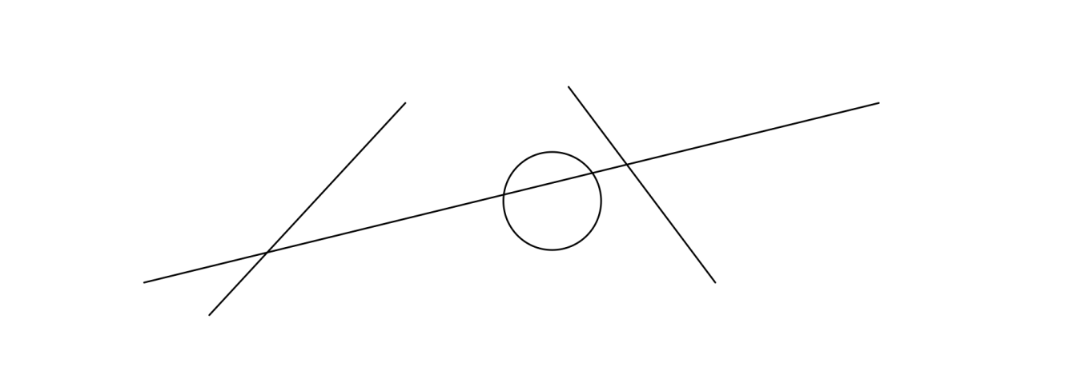

Reference list
Arthur, P. and R. Passini (1992) Wayfinding: People, Signs and Architecture, McGraw Hill, New York.
Backhaus, N. and M. Steinemann (2002) Leitfaden für wissenschaftl. Arbeiten, Schriftenreihe Anthropogeographie, Geographisches Institut, Zurich University UZH, Zurich.
Chapman, M and C. Wykes (1996) Plain Figures, HMSO, London.
Cleveland, W.S. (1994) The Elements of Graphing Data, Hobart Press, Summit.
Dudenredaktion (Hrsg.) (2014) Duden: Die deutsche Rechtschreibung, Dudenverlag, Mannheim.
ETHZ CC (2016) Corporate design, https://www.ethz.ch/services/en/service/communication/corporate-design.html, ETH Zurich Corporate Communications, Zurich, May 2016.
Gowers, E. (1986) The Complete Plain Words, revised by S. Greenbaum and J. Whitcut, HMSO, London.
RSETHZ (2004a) Procedure to address allegations of research misconduct at the ETH Zurich (RSETHZ 415), Rechtsdienst ETH Zurich, Zurich.
RSETHZ (2004b) Disciplinary code of the Swiss Federal Institute of Technology Zurich (RSETHZ 361.1), Rechtsdienst ETH Zurich, Zurich.
RSETHZ (2007) Guidelines for Research Integrity and Good Scientific Practice at the ETH Zurich (RSETHZ 414), Rechtsdienst ETH Zurich, Zurich.
Schweizerische Bundeskanzlei (1996) Leitfaden zur sprachlichen Gleichbehandlung, EDMZ, Bern.
Schweizerische Bundeskanzlei (1998) Leitfaden zur Neuregelung der deutschen Rechtschreibung, EDMZ, Bern.
Tufte, E. (1983) The Visual Display of Quantitative Information, Graphics Press, Cheshire.
Wilkinson, L. (1999) The Grammar of Graphics, Springer, Heidelberg.

Glossary
Text

Appendix Heading

Appendix Subheading

Appendix Subsubheading

Footnote.

